**Seat Number: 2012202**

**Roll Number: MCA2024096**

**Subject: Adavance Web Technology**

1. **Use Disconnected ADO.NET to allow Insert/Delete of Employee records via GridView. Design appriopriate UI for it.**

**CODE:**

using System;

using System.Data;

using System.Data.SqlClient;

using System.Configuration;

using System.Web.UI;

using System.Web.UI.WebControls;

namespace YourNamespace

{

public partial class EmployeeManagement : System.Web.UI.Page

{

// Connection string from Web.config

private string connectionString = ConfigurationManager.ConnectionStrings["EmployeeDBConnectionString"].ToString();

protected void Page_Load(object sender, EventArgs e)

{

if (!IsPostBack)

{

// Bind grid to database data on initial load

BindGrid();

}

}

private void BindGrid()

{

using (SqlConnection conn = new SqlConnection(connectionString))

{

SqlDataAdapter adapter = new SqlDataAdapter("SELECT * FROM Employee", conn);

DataTable dt = new DataTable();

adapter.Fill(dt);

gvEmployees.DataSource = dt;

gvEmployees.DataBind();

}

}

// Insert button click - Insert new employee

protected void btnInsert_Click(object sender, EventArgs e)

{

string employeeName = txtName.Value;

int age = int.Parse(txtAge.Value);

string position = txtPosition.Value;

using (SqlConnection conn = new SqlConnection(connectionString))

{

string query = "INSERT INTO Employee (EmployeeName, Age, Position) VALUES (@EmployeeName, @Age, @Position)";

SqlCommand cmd = new SqlCommand(query, conn);

cmd.Parameters.AddWithValue("@EmployeeName", employeeName);

cmd.Parameters.AddWithValue("@Age", age);

cmd.Parameters.AddWithValue("@Position", position);

conn.Open();

cmd.ExecuteNonQuery();

}

// Rebind the GridView to show the new record

BindGrid();

}

// Edit button click (GridView)

protected void gvEmployees_RowEditing(object sender, GridViewEditEventArgs e)

{

gvEmployees.EditIndex = e.NewEditIndex;

BindGrid();

}

// Cancel editing (GridView)

protected void gvEmployees_RowCancelingEdit(object sender, GridViewCancelEditEventArgs e)

{

gvEmployees.EditIndex = -1;

BindGrid();

}

// Update edited employee (GridView)

protected void gvEmployees_RowUpdating(object sender, GridViewUpdateEventArgs e)

{

int employeeID = Convert.ToInt32(gvEmployees.DataKeys[e.RowIndex].Value);

string employeeName = ((TextBox)gvEmployees.Rows[e.RowIndex].Cells[1].Controls[0]).Text;

int age = int.Parse(((TextBox)gvEmployees.Rows[e.RowIndex].Cells[2].Controls[0]).Text);

string position = ((TextBox)gvEmployees.Rows[e.RowIndex].Cells[3].Controls[0]).Text;

using (SqlConnection conn = new SqlConnection(connectionString))

{

string query = "UPDATE Employee SET EmployeeName = @EmployeeName, Age = @Age, Position = @Position WHERE EmployeeID = @EmployeeID";

SqlCommand cmd = new SqlCommand(query, conn);

cmd.Parameters.AddWithValue("@EmployeeName", employeeName);

cmd.Parameters.AddWithValue("@Age", age);

cmd.Parameters.AddWithValue("@Position", position);

cmd.Parameters.AddWithValue("@EmployeeID", employeeID);

conn.Open();

cmd.ExecuteNonQuery();

}

// Rebind the GridView and cancel editing mode

gvEmployees.EditIndex = -1;

BindGrid();

}

// Delete employee (GridView)

protected void gvEmployees_RowDeleting(object sender, GridViewDeleteEventArgs e)

{

int employeeID = Convert.ToInt32(gvEmployees.DataKeys[e.RowIndex].Value);

using (SqlConnection conn = new SqlConnection(connectionString))

{

string query = "DELETE FROM Employee WHERE EmployeeID = @EmployeeID";

SqlCommand cmd = new SqlCommand(query, conn);

cmd.Parameters.AddWithValue("@EmployeeID", employeeID);

conn.Open();

cmd.ExecuteNonQuery();

}

// Rebind the GridView to reflect the deletion

BindGrid();

}

}

}

**Create table:**

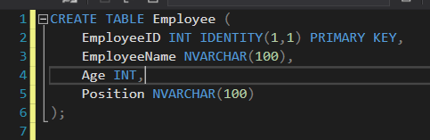

**OUTPUT:**

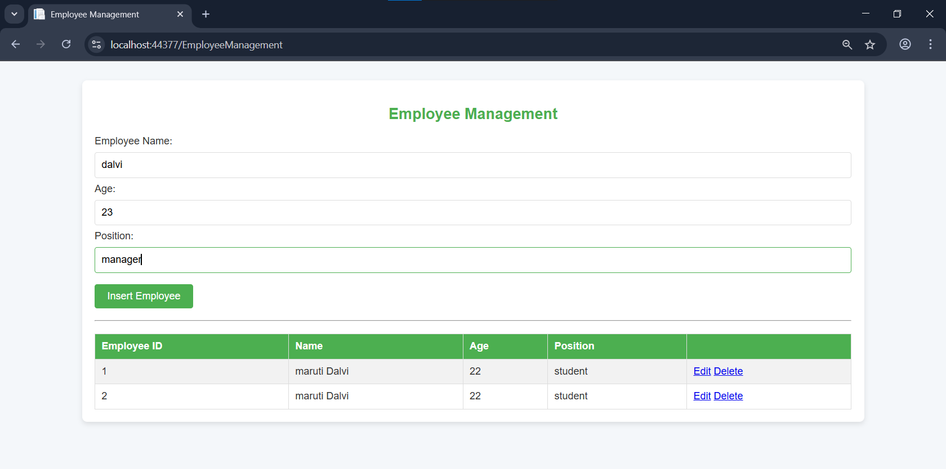

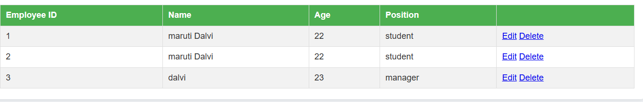

1. **Create a web app to list books usiing checkboclist or dropdownlist. Store selected book in session and show its details on anohter page.**

**Code:**

<%@ Page Language="C#" AutoEventWireup="true" CodeBehind="Default.aspx.cs" Inherits="BookSelectionApp.Default" %>

<!DOCTYPE html>

<html xmlns="http://www.w3.org/1999/xhtml">

<head runat="server">

<title>Select Books</title>

<link href="Content/style.css" rel="stylesheet" type="text/css" />

</head>

<body>

<form id="form1" runat="server">

<div class="container">

<h2>Select Books</h2>

<h3>Choose Multiple Books (Checkbox List)</h3>

<asp:CheckBoxList ID="chkBooks" runat="server" RepeatDirection="Vertical"></asp:CheckBoxList>

<br />

<asp:Button ID="btnSubmitCheckbox" runat="server" Text="Show Details" OnClick="btnSubmitCheckbox_Click" CssClass="btn" />

<hr />

<h3>Or Choose One Book (Dropdown List)</h3>

<asp:DropDownList ID="ddlBooks" runat="server" AppendDataBoundItems="true"></asp:DropDownList>

<asp:Button ID="btnSubmitDropdown" runat="server" Text="Show Details" OnClick="btnSubmitDropdown_Click" CssClass="btn" />

</div>

</form>

</body>

</html>

using System;

using System.Collections.Generic;

using System.Linq;

using System.Web;

namespace BookSelectionApp

{

public static class BookData

{

public static Dictionary<string, Book> Books = new Dictionary<string, Book>()

{

{"book1", new Book{Id="book1", Title="2025", Author="Maruti Dalvi", Description="Dystopian novel"}},

{"book2", new Book{Id="book2", Title="The Hobbit", Author="ABCD", Description="Fantasy adventure"}},

{"book3", new Book{Id="book3", Title="To Kill a Us", Author="Dalvi", Description="Classic novel"}}

};

}

public class Book

{

public string Id { get; set; }

public string Title { get; set; }

public string Author { get; set; }

public string Description { get; set; }

}

}

**Output:**

